

Darshan University

A Project Report on

**“Car service management system ”**

Under the subject

**Software Engineering (2101CS503)**

B. Tech, Semester – V

Computer Science & Engineering Department

|  |  |
| --- | --- |
| Submitted By | |
| Student Name: gadara mihirkumar | Enrollment No.:22010101048 |
| Academic Year  (2023-2024) | |
| Internal Guide  Prof. XYZ  Darshan University | Dean-DIET  Dr. Gopi Sanghani  Darshan University |

|  |  |
| --- | --- |
|  | **Computer Science & Engineering Department**  **Darshan University** |

**DECLARATION**

We hereby declare that the SRS, submitted along with the **Software Engineering** **(2101CS503)** for entitled **“Car service management system”** submitted in partial fulfilment for the Semester-5 of **Bachelor Technology (B. Tech)** in **Computer Science and Engineering (CSE)** Departmentto Darshan University, Rajkot, is a record of the work carried out at **Darshan University, Rajkot** under the supervision of (**Guide name)** and that no part of any of report has been directly copied from any students’ reports, without providing due reference.

Student’s Signature

Date: __________

|  |  |
| --- | --- |
|  | **Computer Science & Engineering Department**  **Darshan University** |

**CERTIFICATE**

This is to certify that the SRS on **“Car service management system” has** been satisfactorily prepared by **Mihir gadara** (22010101048) under my guidance in the fulfillment of the course **Software Engineering (2101CS503)** work during the academic year 2023-2024.

|  |  |  |
| --- | --- | --- |
| Internal Guide  Prof., Guide Name  Darshan University |  | Dean-DIET  Dr. Gopi Sanghani  Darshan University |

**Acknowledgement**

I wish to express my sincere gratitude to my project guide Prof. **Guide name** and all the faculty members for helping me through my project by giving me the necessary suggestions and advices along with their valuable co- ordination in completing this work.

I also thank my parents, friends and all the members of the family for their precious support and encouragement which they had provided in completion of my work. In addition to that, I would also like to mention the Darshan University personals who gave me the permission to use and experience the valuable resources required for the project from the University premises.

Thus, in conclusion to the above said, I once again thank the faculties and members of **Darshan University** for their valuable support in completion of the project.

Thanking You

**Mihir gadara**

**ABSTRACT**

Library management system is a system which aims in developing a computerized system to maintain all the daily work of library. This system will act as a tool to transfer traditional library into digital library. This project has many features which are generally not available in general library system like facility of user login, books search on one click etc. It also has a facility of admin login through which the admin can monitor the whole system.  This system will be designed with the basic features such as librarian can add/view/update/delete books and students' details in it. It has also a facility where student after logging in their accounts can see list of books issued and its issue date and return date and also they can request the librarian to add new books by filling the book request form. The librarian after logging into his account i.e. admin account can generate various reports such as student report , issue report, teacher report and book report.

Main purpose of this system is to reduce human efforts as much as possible.

**Table of Contents**

List of Figures I

List of Tables II

1 Introduction 1

1.1 Product perspective 1

1.2 Product features 1

1.2.1 There are three different users who will be using this product: 1

1.2.2 The features that are required for the Librarian are: 1

1.2.3 The features that are required for the Member are: 1

1.3 Functional Requirement 1

1.3.1 Customer 1

1.3.2 Mechanic 2

1.3.3 Staff 3

1.3.4 Owner 3

1.4 Non-Functional Requirement 4

1.4.1 Performance : 4

1.4.2 Reliability : 4

1.4.3 Usability : 4

1.4.4 Scalability : 4

1.4.5 Security : 4

1.4.6 Accessibility : 4

1.4.7 Maintainability : 4

1.4.8 Compliance : 4

1.4.9 Data Integrity : 4

1.4.10 Backup and Recovery : 4

1.4.11 Monitoring and Logging : 4

2 Design and Implementation Constraints 5

2.1 Use case diagram 5

2.2 Activity diagram and Swimlane diagram 7

2.3 Sequence diagram 9

2.4 State diagram 10

2.5 Class diagram 11

2.6 Data flow diagram 12

2.6.1 Context diagram (level-0) 12

2.6.2 DFD Level-1 12

3 External interface requirement (Screens) 13

3.1 Screen-1: Registration Form 13

3.2 Screen-2: Sign-up nd sing-in page 14

3.3 Screen-3: Payment 15

3.4 Screen-4: Product list page 16

3.5 Screen-5:URL page 17

4 Database design 17

4.1 List of Tables 17

5 Stories and Scenario 20

5.1 Story-1: Schedule a Vehicle Service 20

5.1.1 Scenario# S1.1 20

5.1.2 Scenario# S1.2 20

5.1.3 Scenario# S1.3 21

5.1.4 Scenario# S1.4 21

5.1.5 Scenario# S1.5 21

6 Test cases 21

7 References 26

# List of Figures

Figure 2.1‑1 Use case diagram for car service management system 3

Figure 2.2‑1 Activity diagram for Book Issue 4

Figure 2.2‑2 Swimlane diagram for Book Issue 4

Figure 2.3‑1 Sequence diagram for Book Issue 5

Figure 2.4‑1 State diagram of Book 6

Figure 2.4‑2 State diagram for Librarian 6

Figure 2.5‑1 Class diagram for Library management system 7

Figure 2.6‑1 Context diagram for Library management system 8

Figure 2.6‑2 DFD level-1 for Library management system 8

Figure 2.6‑3 DFD level-2 for Issue book 9

Figure 3.1‑1 Screen-1: Registration Form 10

Figure 3.2‑1 Screen-2: Login Form 11

Figure 3.3‑1 Screen-3: Add borrower book 12

# List of Tables

Table 3.1‑1 Screen element of Registration form 10

Table 3.2‑1 Screen element of Login form 11

Table 3.3‑1 Screen element of Add borrower book 12

Table 4.1‑1 Table: Book 13

Table 4.1‑2 Table: Borrower 13

Table 4.1‑3 Table: Staff 13

Table 4.1‑4 Table: Student 13

# Introduction

## Product perspective

A Car Management System (CMS) is a comprehensive framework designed to manage and optimize the various aspects of owning, operating, and maintaining a fleet of vehicles. It is used by businesses, car rental agencies, and individual car owners to streamline processes, reduce costs, and ensure the efficient utilization of their vehicles

## Product features

### There are three different users who will be using this product:

* Librarian who will be acting as the administrator.
* Member who will be accessing the library.
* Guest who will request for membership.

### The features that are required for the Librarian are:

* Control the movement of books and other material and avoid losing the same.
* Search if you have a specific book in your collection based on the title, author etc.
* Print the spine labels for the book.
* Find what a specific person has borrowed from you. It offers the following modules Cataloguing, Circulation, and Queries.
* Can issue a book to the student.
* Can view the list of books available in each category.
* Can take the book returned from students.
* Add books and their information of the books to the database.
* Edit the information of the existing books.
* Can check the report of the issued Books.
* Can access all the accounts of the students.

### The features that are required for the Member are:

* Can view the different categories of books available in the library.
* Can view the List of books available in each category.
* Can own an account in the library.
* Can view the books issued to him.
* Can put a request for a new book.

## Functional Requirement

### Customer

* Register for an Account: Ability for customers to create a new account using personal information such as name, email, phone number, address, and password.
* Login/Logout: Ability for customers to securely log in and log out of their accounts.
* Profile Management: Ability for customers to view and update their profile information, including contact details and password.
* Book Service Appointment: Ability for customers to view available time slots and book service appointments.
* Reschedule/Cancel Appointment: Ability for customers to reschedule or cancel their service appointments.
* View Appointment History: Ability for customers to view past and upcoming service appointments.
* Select Service Type: Ability for customers to choose the type of service required (e.g., oil change, tire rotation, engine diagnostics).
* Add Service Notes: Ability for customers to add specific notes or instructions for the service.
* Receive Status Updates: Ability for customers to receive real-time updates on the status of their vehicle service (e.g., in progress, completed).
* Track Service Progress: Ability for customers to track the progress of their vehicle service through a dashboard or notifications.
* View Invoice: Ability for customers to view detailed invoices for services rendered.
* Make Payment: Ability for customers to make online payments using various payment methods (credit card, debit card, digital wallets).
* Provide Feedback: Ability for customers to provide feedback or rate the service they received.
* Access Support: Ability for customers to contact customer support for assistance with any issues or inquiries.
* View FAQs: Ability for customers to view frequently asked questions and their answers.
* Receive Notifications: Ability for customers to receive notifications for appointment reminders, service completion, promotional offers, and other relevant updates via email, SMS, or app notifications.
* Add/Remove Vehicles: Ability for customers to add or remove vehicles from their profile.
* View Vehicle History: Ability for customers to view the service history of their vehicles.
* View Promotions: Ability for customers to view available promotioand discounts.
* Apply Promo Codes: Ability for customers to apply promo codes during booking or payment.

### Mechanic

* Manage Profile: Ability for mechanics to view and update their personal and professional information, including contact details and skills.
* View Assigned Work Orders: Ability for mechanics to view the list of work orders assigned to them, including details of the service required.
* Update Work Order Status: Ability for mechanics to update the status of work orders (e.g., assigned, in progress, completed).
* Record Service Details: Ability for mechanics to enter detailed notes and observations about the service performed on each work order.
* Access Service History: Ability for mechanics to view the service history of a vehicle to understand past issues and repairs.
* Request Parts: Ability for mechanics to request specific parts from the inventory manager if needed for the service.
* Track Parts Usage: Ability for mechanics to track the usage of parts during the service.
* Receive Notifications: Ability for mechanics to receive notifications about new work orders, updates to existing work orders, and parts availability.
* Communicate with Service Advisor: Ability for mechanics to communicate with the service advisor for clarifications or additional information regarding a work order.
* Internal Messaging System: Ability for mechanics to use an internal messaging system to communicate with other staff members.
* Generate Service Reports: Ability for mechanics to generate reports on the services they have performed, including details like time spent, parts used, and issues encountered.
* Access Training Materials: Ability for mechanics to access training materials and guidelines to stay updated on best practices and new techniques.
* Technical Documentation: Ability for mechanics to access technical documentation and manuals for reference during service

### Staff

* Assign Work Orders: Ability for service advisors to assign work orders to available mechanics based on skill set and availability.
* Update Work Order Status: Ability for service advisors to update the status of work orders as they progress through the service stages (e.g., created, assigned, in progress, completed).
* Handle Customer Inquiries: Ability for service advisors to respond to customer inquiries regarding their service, work order status, and other concerns.
* Ensure Service Quality: Ability for service advisors to review completed work orders and ensure that all services meet the required quality standards before finalizing them.
* Process Payments: Ability for service advisors to process payments received from customers, ensuring that the correct amounts are recorded and receipts are provided.
* Customer Communication: Ability for service advisors to communicate with customers via phone, email, or messaging regarding their service appointments, estimates, and status updates.
* Access Vehicle History: Ability for service advisors to access the service history of vehicles to provide better service recommendations and estimates.
* Generate Service Reports: Ability for service advisors to generate reports on the services provided, including work orders completed, parts used, and time taken for each service.
* Customer Feedback Reports: Ability for service advisors to generate and review reports based on customer feedback and ratings.
* Update Inventory: Ability for the inventory manager to add, update, or remove inventory items, including parts, tools, and supplies.
* Set Reorder Points: Ability for the inventory manager to set reorder points for critical parts and supplies to ensure timely restocking.
* Manage Supplier Information: Ability for the inventory manager to maintain a database of supplier details, including contact information and terms of purchase.
* Place Orders: Ability for the inventory manager to place orders with suppliers for new inventory items or restocking existing items.
* Track Order Status: Ability for the inventory manager to track the status of orders placed with suppliers, including expected delivery dates.

### Owner

* Comprehensive Dashboard: Ability for the owner to view a high-level dashboard summarizing key metrics such as revenue, expenses, work orders, customer feedback, and inventory levels.
* Customizable Reports: Ability to generate and customize reports on various aspects of the business, including financial performance, service efficiency, customer satisfaction, and inventory management
* View Financial Reports: Ability to view detailed financial reports, including profit and loss statements, balance sheets, cash flow reports, and expense reports.
* Monitor Revenue and Expenses: Ability to monitor revenue streams, track expenses, and analyze financial trends to make informed business decisions.
* Set Business Goals: Ability to set business goals and track progress towards achieving them.
* Analyze Business Performance: Ability to analyze overall business performance and identify areas for improvement or expansion.
* Review Permissions: Ability to review and modify user permissions to ensure appropriate access levels are maintained.
* Monitor Service Efficiency: Ability to monitor the efficiency and effectiveness of the service operations, including work order management, service completion times, and customer satisfaction.
* Approve Key Decisions: Ability to review and approve key operational decisions, such as major purchases, new service offerings, or significant changes in pricing.
* Review Customer Feedback: Ability to review customer feedback and ratings to assess customer satisfaction and identify areas for improvement.
* Engage with Key Customers: Ability to engage with key customers, especially in cases of high-value clients or critical feedback.
* Monitor Inventory Levels: Ability to monitor overall inventory levels and ensure efficient inventory management practices.
* Oversee Supplier Relations: Ability to oversee supplier relationships, review major supplier agreements, and ensure the best terms for procurement.

## Non-Functional Requirement

### Performance :

The system should be able to handle multiple users simultaneously without significant delays

### Reliability :

The system should be have high availability and minimal downtime

### Usability :

The user interface should be intuitive and easy to navigate for all types of users

### Scalability :

The system should be scalable to accommodate growth in data volume and user load

### Security :

The system must protect sensitive data with encryption and secure access controls

### Accessibility :

The system should be able to accessible to users with disabilities, complying with accessibility standards

### Maintainability :

The system should be able to easy to maintain and update without extensive downtime

### Compliance :

The system should comply with relevant legal and regulatory standards

### Data Integrity :

The system must ensure the accuracy and consistency of data throughout its life cycle

### Backup and Recovery :

The system should have mechanisms for data backup and recovery in case of any system failures

### Monitoring and Logging :

The system should have monitoring tools to track usage patterns and log system activities

# Design and Implementation Constraints

## Use case diagram

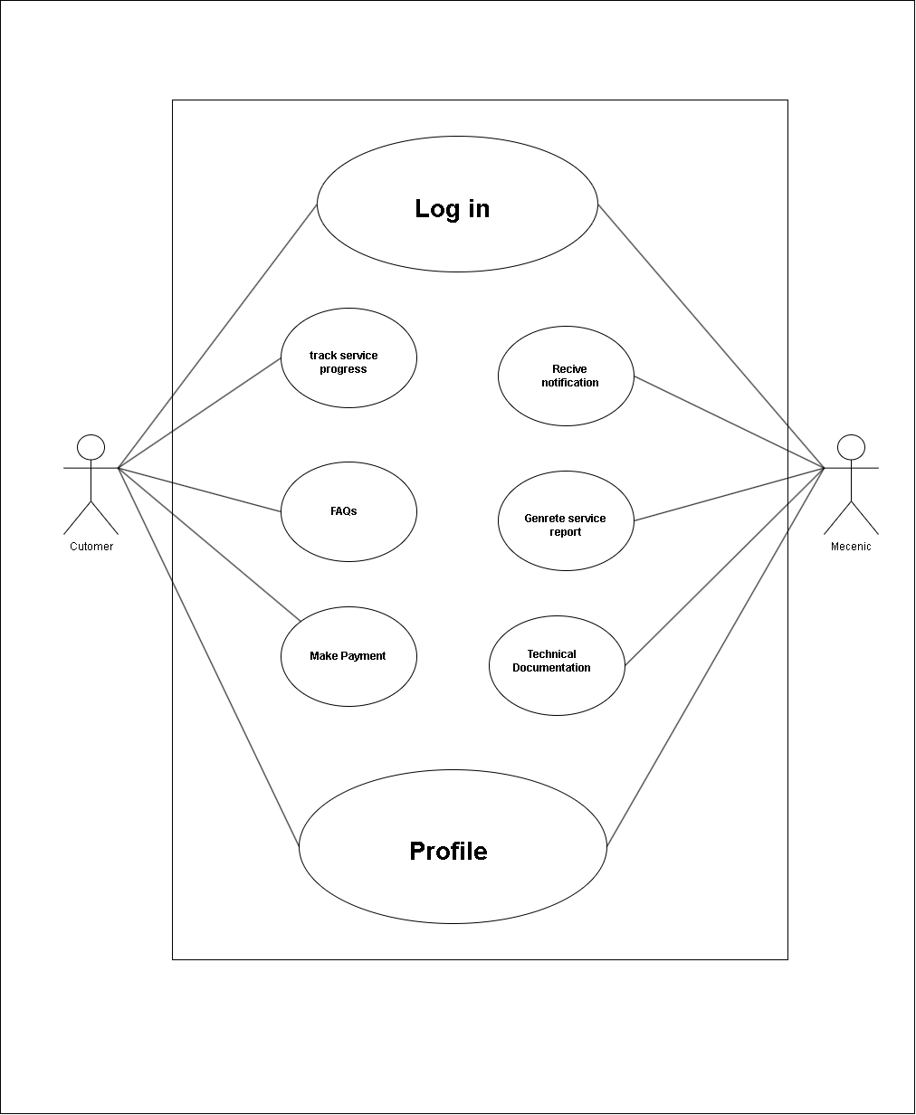

Figure 2.1‑1 Use case diagram for car service management system

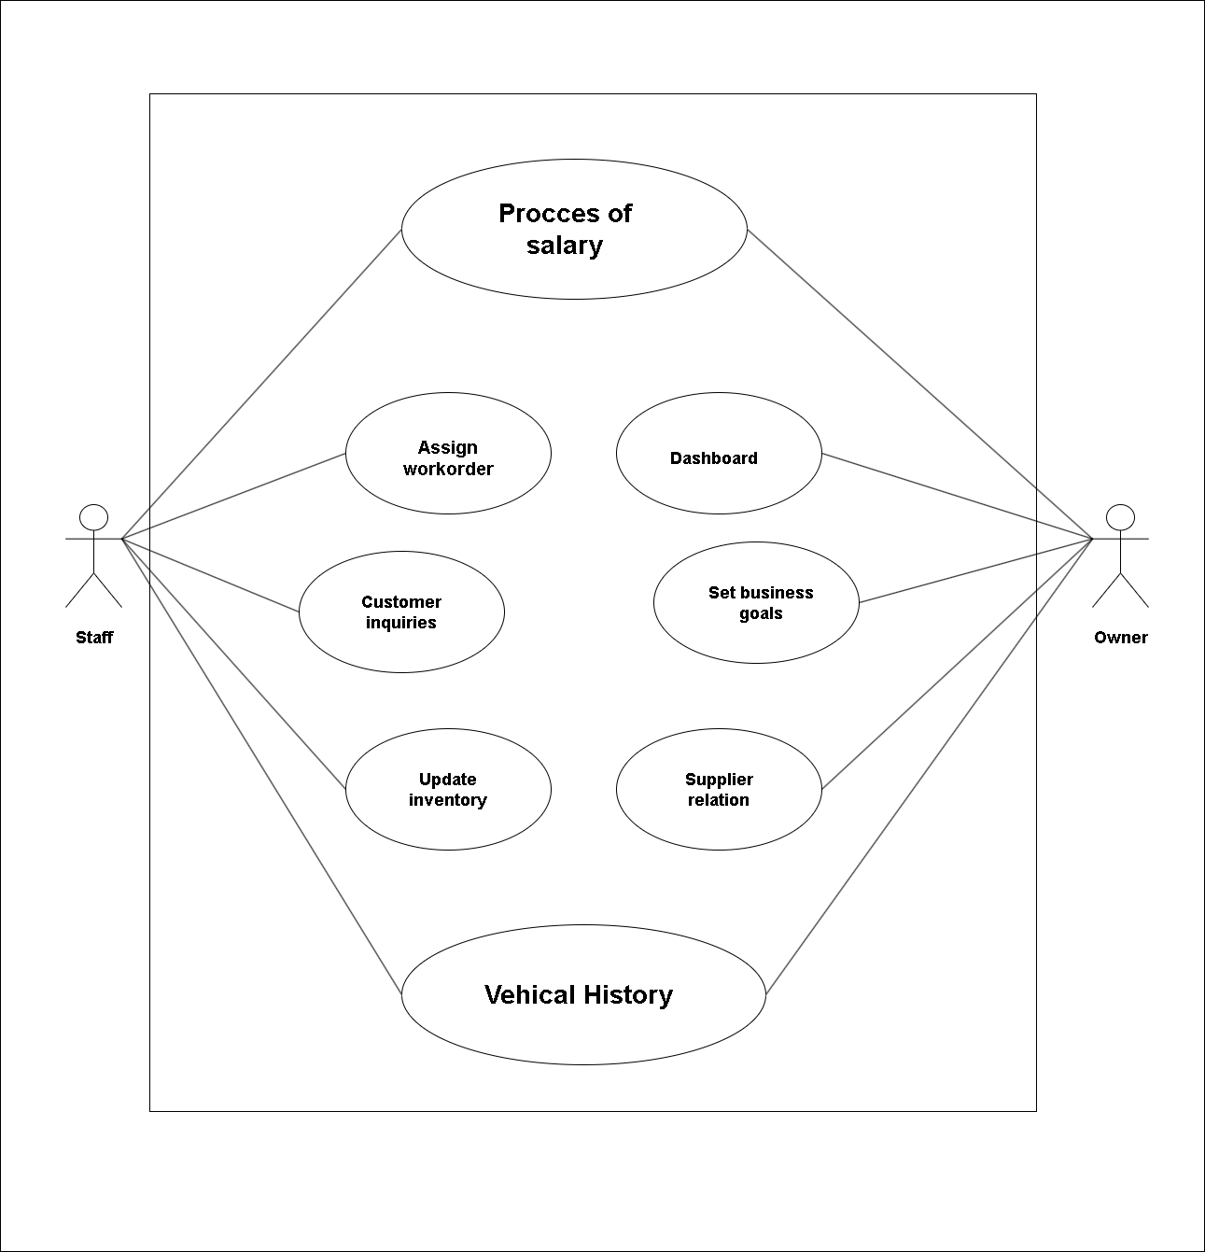

## Activity diagram and Swimlane diagram

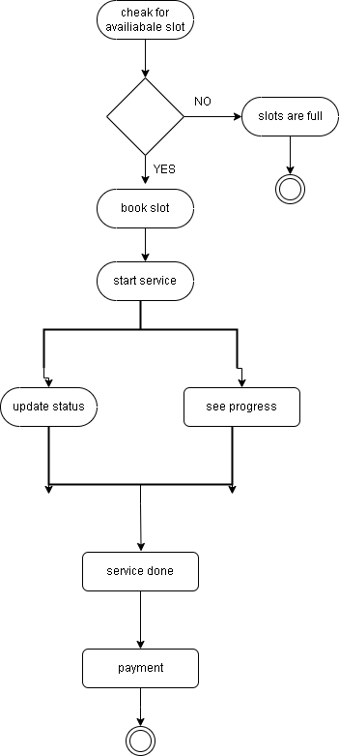

Figure 2.2‑1 Activity diagram for car service system

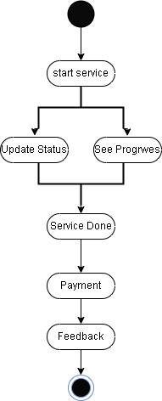

Figure 2.2‑2 Activity diagram for payment and feedback

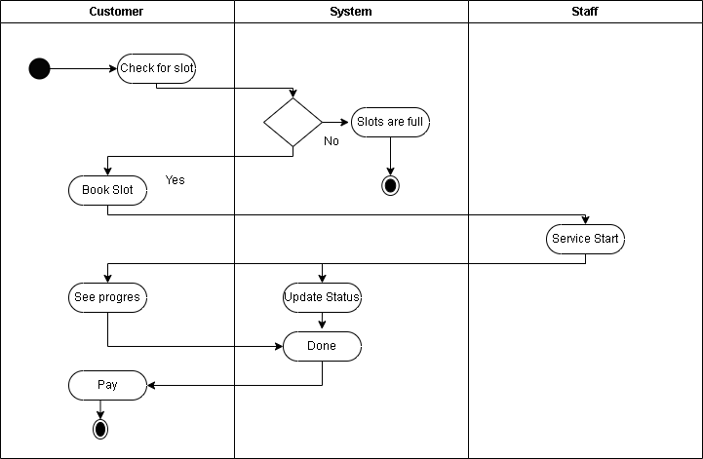

Figure 2.2‑3 Swimlane diagram for slot booking

## Sequence diagram

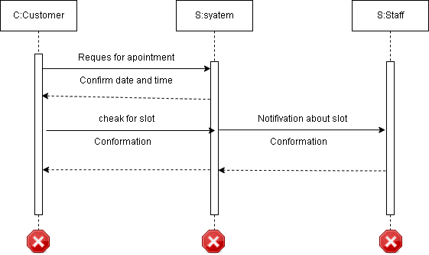

Figure 2.3‑1 Sequence diagram for slot booking

## State diagram

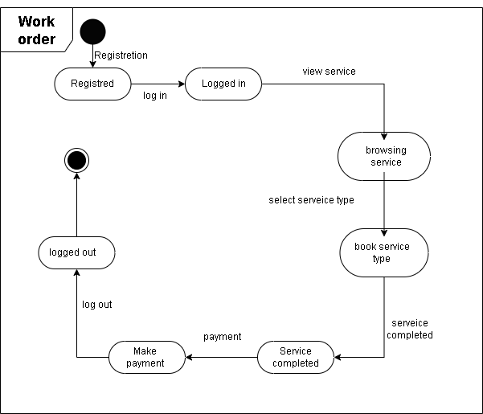

Figure 2.4‑1 State diagram of car service

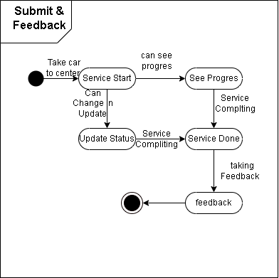

Figure 2.4‑2 State diagram for submit and feedback

## Class diagram

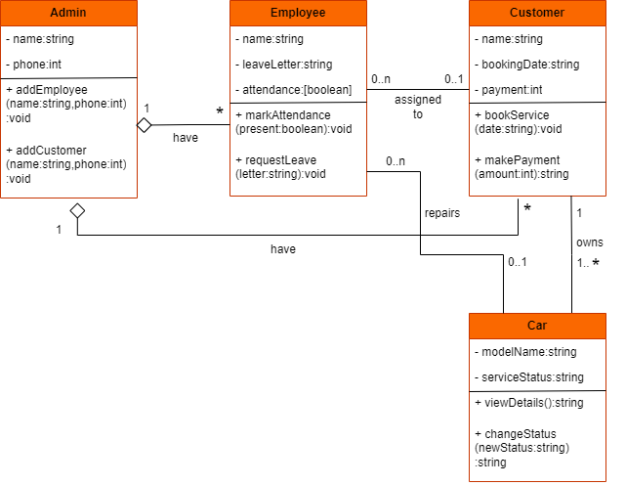

Figure 2.5‑1 Class diagram for Library management system

## Data flow diagram

### Context diagram (level-0)

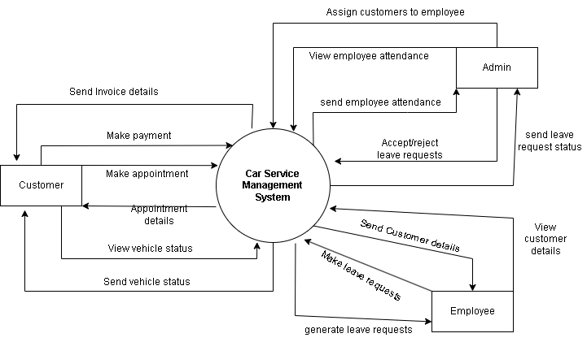

Figure 2.6‑1 Context diagram for Car service management system

### DFD Level-1

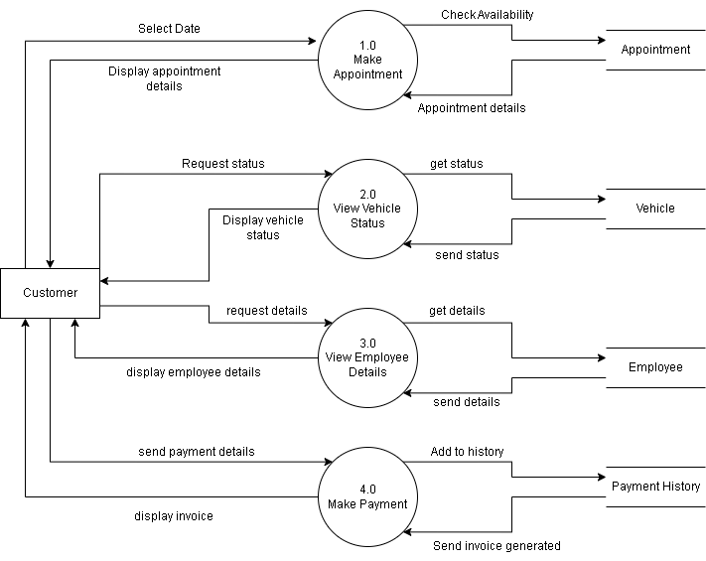

Figure 2.6‑2 DFD level-1 for Car service management system

# External interface requirement (Screens)

## Screen-1: Registration Form

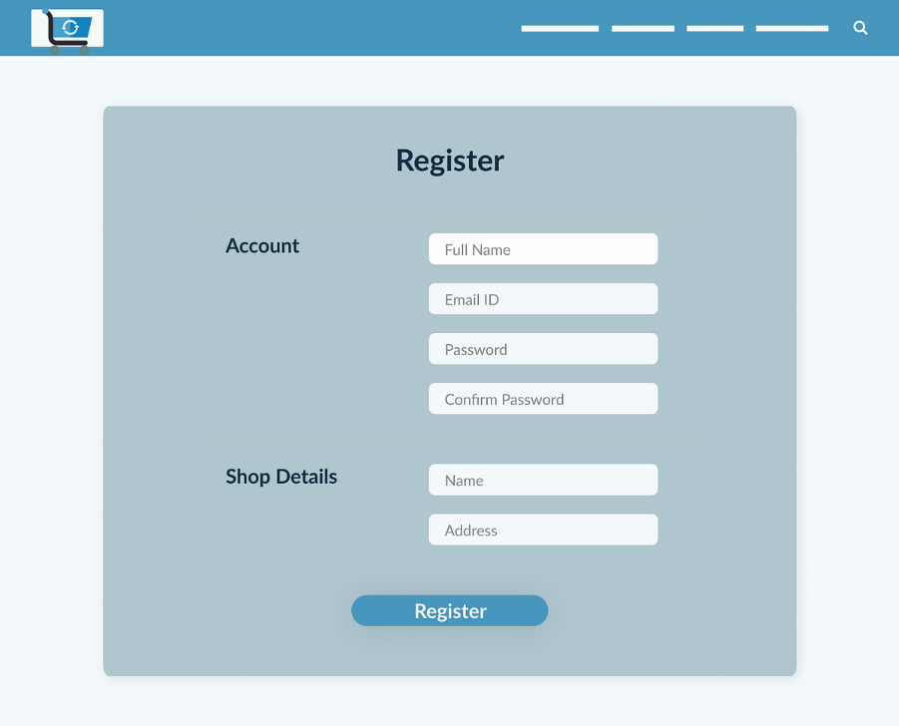

Figure 3.1‑1 Screen-1: Registration Form

**Purpose:** This form will allow the target end-users to register in the system. To register , the following information will be encoded in the system.

Table 3.1‑1 Screen element of Registration form

|  |  |  |  |  |  |
| --- | --- | --- | --- | --- | --- |
| Sr. | Screen Element | Input Type | O/M | 1/N | Description |
| 1 | Icon | Image | M | 1 | Site logo |
| 2 | Search | Text | M | 1 | Search field |
| 3 | FullName | text | M | 1 | Insert Full Name |
| 4 | Email | Text | M | 1 | Insert Email |
| 5 | Password | Text | M | 1 | Insert Passoword |
| 6 | Confirm password | Text | M | 1 | Insert password again |
| 7 | Product name | Text | M | 1 | Product name |
| 8 | Addresh | Text | M | 1 | Addres bar |

## Screen-2: Sign-up nd sing-in page

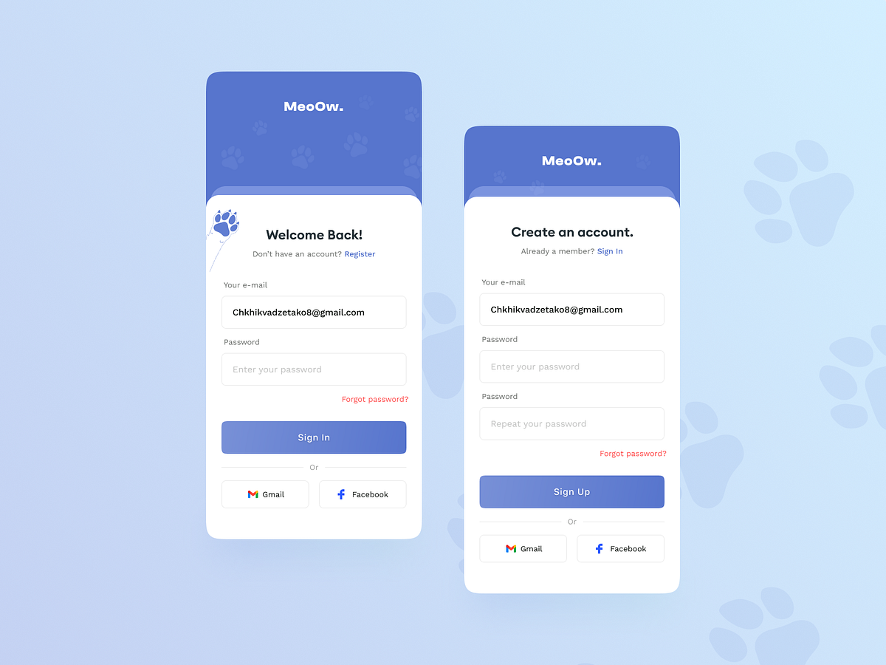

Figure 3.2‑1 Screen-2: sign-up and sign-in

**Purpose:** The sign-up page allows new users to create an account by providing necessary information, enabling personalized access to services. The sign-in page lets existing users securely access their accounts using their credentials.

Table 3.2‑1 Screen element of sign-up and sign-in

|  |  |  |  |  |  |
| --- | --- | --- | --- | --- | --- |
| Sr. | Screen Element | Input Type | O/M | 1/N | Description |
| 1 | e-mail | Text | M | 1 | Email |
| 2 | password | Text | M | 1 | password |
| 3 | Forgot password | Link | M | 1 | Can change password |
| 4 | Sign in | Button | M | 1 | Sign in |
| 5 | Gmail | Button | M | 1 | Gmail |
| 6 | Facebook | Button | M | 1 | Facebook |

## Screen-3: Payment

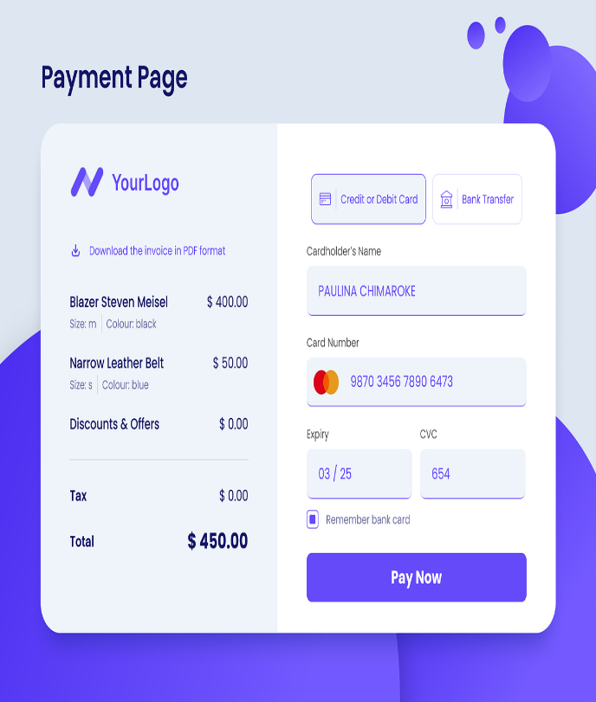

Figure 3.3‑1 Screen-3: Payment

**Purpose:** The purpose of payment is to facilitate the transfer of money in exchange for goods, services, or to full fill financial obligations. It enables transactions between parties, ensuring that the seller or service provider is compensated.

Table 3.3‑1 Screen element of Add borrower book

|  |  |  |  |  |  |
| --- | --- | --- | --- | --- | --- |
| Sr. | Screen Element | Input Type | O/M | 1/N | Description |
| 1 | Pdf-format | Link | M | 1 | Pdf view |
| 2 | Credit & debit | Button | M | 1 | Credit card |
| 3 | Bank transfer | Button | M | 1 | Bank options |
| 4 | Holder name | Text | M | 1 | Name |
| 5 | Card number | Text | M | 1 | Card number |
| 6 | Expiry | Datetime | M | 1 | Expiry date |
| 7 | Remember bank | Check box | O | 1 | Remember bank |
| 8 | Pay now | Button | M | 1 | Pay |
| 9 | CVC | Text | M | 1 | CVC |

## Screen-4: Product list page

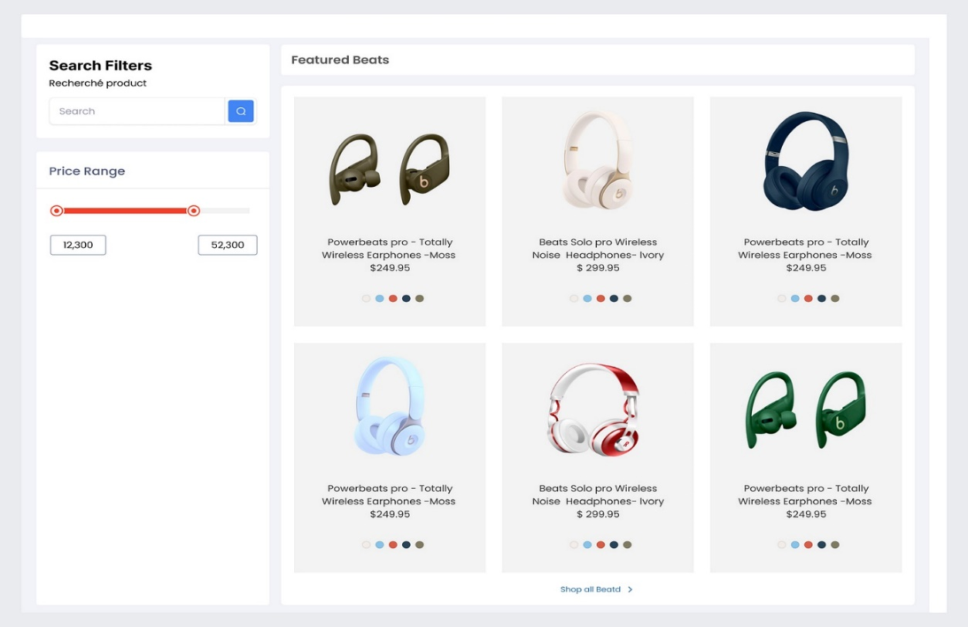

Figure 3.3‑1 Screen-3: Payment

**Purpose:** A product list is a detailed catalog or inventory that showcases items or services available for purchase. It typically includes product names, descriptions, prices, images, and other relevant details to help customers make informed buying decisions.

Table 3.3‑1 Screen element of Add borrower book

|  |  |  |  |  |  |
| --- | --- | --- | --- | --- | --- |
| Sr. | Screen Element | Input Type | O/M | 1/N | Description |
| 1 | Search filed | Text | M | 1 | Serch text |
| 2 | Search button | Button | M | 1 | Search |
| 3 | Card view | Button | M | N | Show card |
| 4 | Card color | Button | M | N | Can change color |
| 5 | Price | Button | M | 1 | Show price |
| 6 | Price scroll | Scroller | M | 1 | Price range |

## Screen-5:URL page

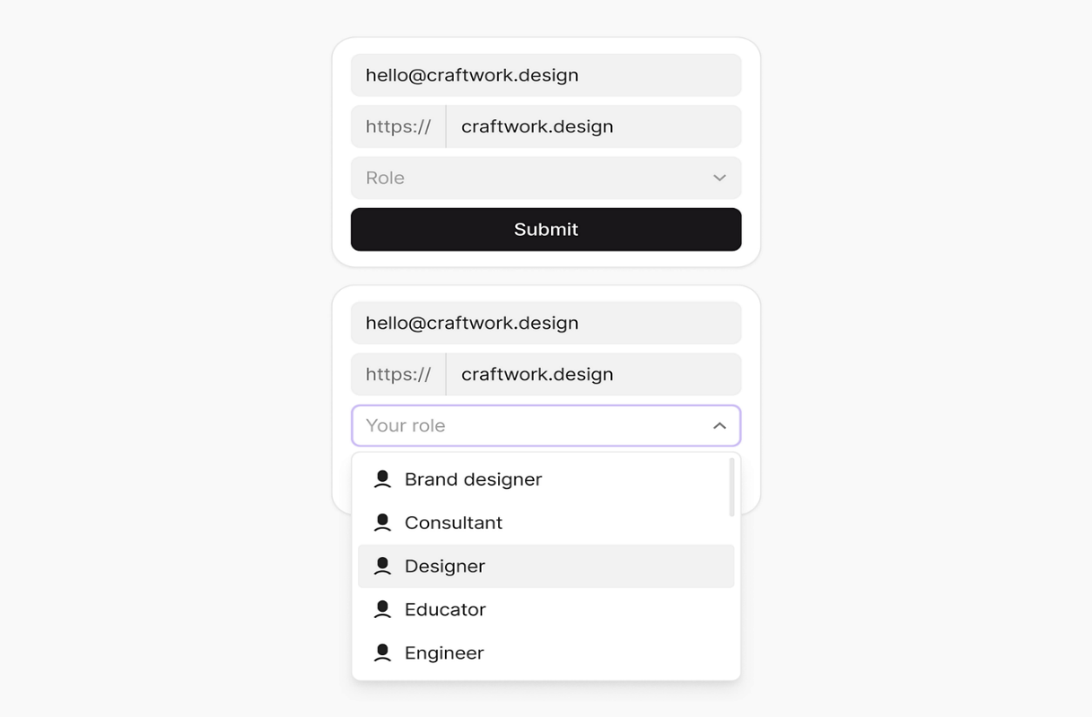

Figure 3.3‑1 Screen-3: Payment

**Purpose:** The purpose of the interface shown in the image is to collect user information through a form. Specifically, it appears to be part of a sign-up or registration process where the user is required to enter their email address, website URL, and select their role (such as Designer, Consultant, etc.) from a dropdown menu. The "Submit" button is used to send this information for processing, likely to create a user profile or account based on the provided details.

Table 3.3‑1 Screen element of Add borrower book

|  |  |  |  |  |  |
| --- | --- | --- | --- | --- | --- |
| Sr. | Screen Element | Input Type | O/M | 1/N | Description |
| 1 | Email | Text | M | N | Email |
| 2 | Web-link | Text | M | N | Link |
| 3 | Role | Dropdown | M | 1 | All role |
| 4 | Submit | Button | M | 1 | submit |
| 5 | Roles | Button | M | N | job roles |

# Database design

## List of Tables

* Customer
* Mechenic
* Inventory
* Appointment
* Payment

Table 4.1‑1 Table: Customer

|  |  |  |  |  |
| --- | --- | --- | --- | --- |
| Column | Data Type | Null | Keys & Constrains | Default Value & Description |
| CustomerID | INT | NO | Primary Key, Auto-increment | Unique identifier for each customer |
| Name | VARCHAR(100) | NO |  | Customer's full name |
| ContactInformation | VARCHAR(255) | NO |  | Customer's contact details (phone, email) |
| VehicleInformation | TEXT | YES |  | Details about the customer's vehicles |
| RegistrationDate | DATE | NO |  | Date when the customer registered in the system |
| Address | VARCHAR(255) | YES |  | Customer's physical address |

Table 4.1‑2 Table: Mechenic

|  |  |  |  |  |
| --- | --- | --- | --- | --- |
| Column | Data Type | Null | Keys & Constrains | Default Value & Description |
| MechanicID | INT | NO | Primary Key, Auto-increment | identifier for each mechanic |
| Name | VARCHAR(100) | NO |  | Mechanic full name |
| Expertise | VARCHAR(100) | YES |  | Mechanic's area of expertise |
| ContactInformation | VARCHAR(255) | YES |  | Mechanic's contact details |
| AssignedTasks | TEXT | YES |  | List of tasks or work orders assigned to the mechanic |
| WorkHistory | TEXT | YES |  | Record of past work completed by the mechanic |
| Certification | VARCHAR(255) | YES |  | Certificatio |

Table 4.1‑3 Table: Inventory

|  |  |  |  |  |
| --- | --- | --- | --- | --- |
| Column | Data Type | Null | Keys & Constrains | Default Value & Description |
| InventoryID | INT | No | Primary Key, Auto-increment | Unique id for each inventory |
| Part name | Varchar(50) | No |  | Name of part |
| partNumber | Varchar(50) | No |  | Internal part number |
| quantity | Int | No |  | Unit available in stock |
| Supplier ID | Int | No | Foreign Key | Id of supplier |
| Price | Decimal(10,2) | no |  | Price of part |
| Location | Varchar(50) | no |  | Location of part |
| Recorder level | Int | No |  | Stock level at which new orders should be placed |

Table 4.1‑4 Table: Appointment

|  |  |  |  |  |
| --- | --- | --- | --- | --- |
| Column | Data Type | Null | Keys & Constrains | Default Value & Description |
| AppointmentID | INT | NO | Primary Key, Auto-increment | Unique identifier for each appointment |
| CustomerID | INT | NO | Foreign Key | Identifier linking to the customer |
| VehicleInformation | VARCHAR(255) | NO |  | Details about the vehicle scheduled for service |
| ServiceType | VARCHAR(100) | NO |  | Type of service requested |
| AppointmentDate | DATETIME | NO |  | Date and time of the appointment |
| Status | VARCHAR(50) | NO |  | Current status of the appointment |

Table 4.1‑5 Table: payment

|  |  |  |  |  |
| --- | --- | --- | --- | --- |
| Column | Data Type | Null | Keys & Constrains | Default Value & Description |
| PaymentID | int | No | Primary key | Unique identity of each payment |
| invoiceID | Int | No | Foreign Key | Identifier linking to the corresponding invoice. |
| CustomerID | Int | No | Foreign key | Unique customer id |
| Paymentmethod | Varchar(50) | no |  | Methods of payment |
| Amount | Decimal(10,2) | No |  | Total amount of part |
| Paymentdate | Datetime | No |  | Date of payment |
| Transaction id | Varchar(50) | No |  | Unique id of each transaction |
| status | Varchar(50) | no |  | Status of payment |

# Stories and Scenario

## Story-1: Schedule a Vehicle Service

|  |  |  |
| --- | --- | --- |
| *Story # S1* | : | As a customer  I want to took a vehicle service appointment  So that my car is serviced efficiently and on time |
| Priority | **:** | High |
| Estimate | **:** | XL |
| Reason | **:** | Scheduling a service ensures the customer gets timely vehicle maintenance, improves service workflow, and enhances customer satisfaction by ensuring cars are ready as per their convenience. |

### Scenario# S1.1

|  |  |  |
| --- | --- | --- |
| *Scenario# S1.1* | : | Booking a Service with Valid Information |
| Prerequisite | **:** | : The customer is logged into the Car Service Management System |
| Acceptance Criteria | **:** | **Given:** The customer is on the appointment booking page**.**  **When:**  The customer selects the type of service (e.g., oil change, brake inspection, etc.).  The customer enters vehicle details (make, model, VIN).  The customer selects a preferred date and time for the service.  The customer clicks the "Book Appointment" button.  **Then:** The system schedules the appointment and confirms with a message that includes the appointment details and service advisor information**.** |

### Scenario# S1.2

|  |  |  |
| --- | --- | --- |
| *Scenario# S1.2* | : | Rescheduling an Appointment |
| Prerequisite | **:** | The customer has an existing appointment scheduled |
| Acceptance Criteria | **:** | **Given:** The customer navigates to the “My Appointments” page.  **When:**  The customer selects the existing appointment.  The customer chooses the "Reschedule" option.  The customer selects a new date and time and clicks "Save Changes."  **Then:** The system updates the appointment and sends a confirmation message with the updated time and date. |

### Scenario# S1.3

|  |  |  |
| --- | --- | --- |
| *Scenario# S1.3* | : | Canceling a Service Appointment |
| Prerequisite | **:** | The customer has an existing service appointment. |
| Acceptance Criteria | **:** | **Given**: The customer is on the "My Appointments" page.  **When**:  The customer selects an upcoming appointment.  The customer clicks the "Cancel Appointment" button.  The customer confirms the cancellation.  **Then:** The system cancels the appointment and sends a cancellation confirmation |

### Scenario# S1.4

|  |  |  |
| --- | --- | --- |
| *Scenario# S1.4* | : | Checking Appointment Status |
| Prerequisite | **:** | The customer has booked an appointment. |
| Acceptance Criteria | **:** | **Given**: The customer navigates to the "My Appointments" page.  **When**: The customer selects an appointment.  **Then:** The system shows the current status of the appointment (e.g., Scheduled, In Progress, Completed) and provides any relevant details or updates. |

### Scenario# S1.5

|  |  |  |
| --- | --- | --- |
| *Scenario# S1.5* | : | Receiving Service Reminders |
| Prerequisite | **:** | The customer has booked an appointment for a future date. |
| Acceptance Criteria | **:** | **Given**: The system tracks upcoming appointments.  **When**: The appointment date is approaching (e.g., 24 hours before).  **Then:** The system sends a reminder notification (via email or SMS) with details about the scheduled service and instructions to the customer. |

# Test cases

|  |  |  |  |
| --- | --- | --- | --- |
| Project Name: | CarServiceManagement | Test Designed by: | M . N . Patel |
| Module Name: | **Payment** | **Test Designed date:** | 01-10-2022 |
| Release Version: | **1.0** | **Test Executed by:** | **R. B. Gondaliya** |
|  |  | **Test Execution date:** | 15-01-2023 |

|  |  |  |  |  |
| --- | --- | --- | --- | --- |
| Pre-condition: Web application should be accessible | | | | |
| Test Case ID | **Test Title** | **Test Type** | **Description** | **Test Case ID** |
| TC_001 | Verify payment page elements | Functional | verify that all elements are availabe on payment page | TC_001 |
| TC_002 | Card expired | Functional | Verification failed if card was expired | TC_002 |
| TC_003 | Method validation | GUI | Make sure all the payment method is from listed methods | TC_003 |
| TC_004 | Payment confirmation email | Functional | After payment confirmation email will generates | TC_004 |

|  |  |
| --- | --- |
| **Test Case Title** | Add New Car Service Appointment |
| **Test Type** | Functional |
| **Test Priority** | High |
| **Pre-condition** | Validate that a new car service appointment can be added successfully. |

|  |  |  |  |  |  |  |  |
| --- | --- | --- | --- | --- | --- | --- | --- |
| **Test Step** | **Test Case Description** | **Expected Result** | **Actual Result** | **Status** | **Comment** | **Data** | **Bug ID** |
| 1 | Enter customer details (Name, Contact, etc.) | Customer details are entered and validated | Customer details entered and validated successfully | Pass | Data validation worked correctly | Customer Name: John Doe, Contact: 1234567890 |  |
| 2 | Select car details (Make, Model, Year) | Car details are selected and validated | Car details selected and validated successfully | Pass | Car data correctly selected | Car Make: Toyota, Model: Camry, Year: 2020 |  |
| 3 | Select appointment date and time | Date and time are selected and available | Date and time selected, time slot available | Pass | Appointment slot available and confirmed | Appointment Date: 2024-09-10, Time: 10:00 AM |  |
| 4 | Choose the type of service (e.g., oil change) | Service type is selected and validated | Service type selected successfully | Pass | Service type selection processed correctly | Service Type: Oil Change |  |

|  |  |
| --- | --- |
| **Test Case Title** | **Login to web application with invalid credential** |
| **Test Type** | **Functional** |
| **Test Priority** | **Medium** |
| **Pre-condition** | **Web application should be accessible** |

|  |  |  |  |  |  |  |  |
| --- | --- | --- | --- | --- | --- | --- | --- |
| **Test Step** | **Test Case Description** | **Expected Result** | **Actual Result** | **Status** | **Comment** | **Data** | **Bug ID** |
| 1 | Search for the appointment by appointment ID | Appointment with matching ID is displayed in search results | Appointment found in the system | Pass | Search function returned the correct appointment | Appointment ID |  |
| 2 | Open the appointment details page | Appointment details page is displayed | Appointment details displayed correctly | Pass | Details page opened without errors | Appointment ID: 101 |  |
| 3 | Update service status to "In Progress" | Status is updated to "In Progress" and saved successfully | Status updated and saved successfully | Pass | Status change reflected in the system | New Status: In Progress |  |
| 4 | Verify the updated status in the appointment list | The updated status is shown as "In Progress" | Status updated and shown as "In Progress" | Pass | Status change visible in the list | Appointment ID: 101 |  |

|  |  |
| --- | --- |
| **Test Case Title** | **Delete Car Service Appointment** |
| **Test Type** | **GUI** |
| **Test Priority** | **Medium** |
| **Pre-condition** | **Web application should be accessible** |

|  |  |  |  |  |  |  |  |
| --- | --- | --- | --- | --- | --- | --- | --- |
| **Test Step** | **Test Case Description** | **Expected Result** | **Actual Result** | **Status** | **Comment** | **Data** | **Bug ID** |
| 1 | Navigate to the "Appointments" page | The "Appointments" page is displayed successfully | Appointments page displayed correctly | Pass | Page loaded successfully | N/A |  |
| 2 | Search for the appointment by appointment ID | Appointment with matching ID is displayed in search results | Appointment found in the system | Pass | Appointment search returned correct result | Appointment ID: 102 |  |
| 3 | Open the appointment details page | Appointment details page is displayed | Appointment details displayed correctly | Pass | Details page opened without errors | Appointment ID: 102 |  |
| 4 | Click the "Delete" button | A confirmation dialog is displayed | Confirmation dialog appeared as expected | Pass | Confirmation popup displayed | N/A |  |

|  |  |
| --- | --- |
| **Test Case Title** | **Add New Car Service Appointment** |
| **Test Type** | **Functional** |
| **Test Priority** | **High** |
| **Pre-condition** | **Validate that a new car service appointment can be added successfully.** |

|  |  |  |  |  |  |  |  |
| --- | --- | --- | --- | --- | --- | --- | --- |
| **Test Step** | **Test Case Description** | **Expected Result** | **Actual Result** | **Status** | **Comment** | **Data** | **BUG ID** |
| 1 | Navigate to the "Appointments" page | The "Appointments" page is displayed successfully | Appointments page displayed correctly | Pass | Page loaded successfully | N/A |  |
| 2 | Search for the appointment by appointment ID | Appointment with matching ID is displayed in search results | Appointment found in the system | Pass | Appointment search returned correct result | Appointment ID: 103 |  |
| 3 | Open the appointment details page | Appointment details page is displayed | Appointment details displayed correctly | Pass | Details page opened without errors | Appointment ID: 103 |  |
| 4 | Update service status to "Completed" | Status is updated to "Completed" and saved successfully | Status updated and saved successfully | Pass | Status change reflected in the system | New Status: Completed |  |

# References

* http://www.w3schools.com/html/html_intro.asp
* https://www.w3schools.com/php/default.asp
* https://www.javatpoint.com/uml